Abstract title (sample)
F. Author¹ and S. Author²
¹Institute, Town, Country
² another Institute, another town, another country
E-mail: name@mymail.cy

Introduction
The extended abstract should be headed by a title, name(s) and complete address(es) of the author(s). Please underline the name of the author who will present the paper and leave a 3.0 cm margin on top and 2.5 cm margin on all other sides. As font you should use Arial or Helvetica, 11pt with a line spacing of 16pt. The abstract can contain Figures, Tables and References, but the length of the abstract should not exceed Three DIN A4 page.
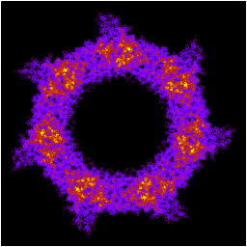

Fig. 1 Figures must be numbered and a caption should be added

Leave appropriate space after the caption

Methods
Please ad as many chapters as necessary.

Results

Discussion

References

- F. Author, Journal volume, page (year)
- S. Author, Journal 100, 101101 (2009)

